Fast Online Algorithm for Support Vector Machines Model and Experimental Studies

Vojislav Kecman
Department of Computer Science
Virginia Commonwealth University
Richmond, USA
vkecman@vcu.edu
Gabriella Melki
Department of Computer Science
Virginia Commonwealth University
Richmond, USA
melkiga@vcu.edu

Abstract—A novel online, i.e. stochastic, learning algorithm in a primal domain is introduced and its performance is compared to the Sequential Minimal Optimization (SMO) based algorithm for training L1 Support Vector Machines (SVMs) implemented within MATLAB's SVM solver fitcsvm. Their performances are compared on both real and artificial datasets, which contain up to 15,000 samples. These datasets belong to the small and medium class of datasets. We have shown that classic online learning algorithms implemented in the primal domain can be both extremely efficient and faster up to two orders of magnitude in respect to SMO algorithm. In particular, unlike the SMO algorithm, our simulations show that the online algorithm OL SVM does not depend on SVM design parameters (penalty parameter C and Gaussian kernel shape parameter σ or on the order of the polynomial kernel). This property is very beneficial for the SVMs' training. Hence, online (stochastic gradient) training in primal seems to be both the strongest candidate and a very promising approach for classifying large and ultra-large datasets. Paper also compares OL SVM with the established stochastic gradient algorithms, Norma and a novel version of an on line SVM training algorithm dubbed here as Pegaz.
Keywords—Online learning, Stochastic gradient learning, Training SVM in primal, Support vector machines

Introduction
Support Vector Machines (SVMs) are known as both accurate and fast (and consequently very popular) machine learning i.e. data mining, tools [1-5]. In the original setting, for the so-called L1 SVM, the learning algorithm is based on solving a quadratic programming problem in a dual domain subject to the set of block constraints and a single equality constraint. Historically, this was the leading approach for solving classification and regression tasks by SVMs. Recently several authors have proposed the use of a standard stochastic gradient approach for SVMs while solving machine learning problems [5-8]. The mentioned approaches are extended variants of a classic kernel perceptron algorithm [9]. The main difference between these, otherwise close, approaches presented in [5-8] and in this paper originate from the minimization of slightly different loss (i.e., cost) functions while training the SVM. In [5-8] the cost function was the regularized hinge loss given by (1), while in here, the hinge loss, or soft margin loss, (2) is minimized only. [10] presents the justification for not using the regularization term, 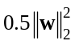, shown in (1). Our algorithm presented in the paper was obtained by minimizing the soft margin loss function (2) and it is close to the approach in [9]. The experiments done here also confirm the statements and findings in [10]. This will be shown in the results section of the paper. The two loss functions used in developing stochastic gradient based algorithms for SVMs are given below.
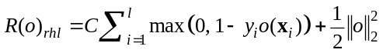, | (1)

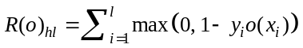, | (2)

Where o is the output (decision function) of the SVM for a given input vector x_{i}, y_{i} is the label for sample x_{i}, l is the number of samples i.e., cardinality of the dataset, and C stands for the regularization penalty parameter. The SVMs' hinge loss is given in (2) and it is also the first term in (1). The last term on the right hand side of (1) is the regularization term of the hinge loss function. Typically, this regularization is expressed by squaring the norm of the weight vector w which, geometrically, determines the width of the margin between the two classes. The penalty parameter C is a trade-off parameter between the size of the margin and the size of the slack variables [1]. The smaller C, the larger the margin creating a more robust classifier. Increasing C to infinity leads to the hard margin classifier, if the data are linearly separable. The proper value of C is not known in advance, and it is obtained by cross-validation. Indices rhl and hl stand for regularized hinge loss and hinge loss respectively.

Three Online SVMs Algorithms
Here the gradient descent is used for minimization of loss functions (1) and (2). A classic gradient descent optimizes given parameter of interest p as
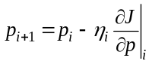, | (3)

where J stands for the loss function being minimized and η_{i} is a learning rate defining the stepsize at each iteration. Here, we will present two algorithms as given in [5-8] first. In both cases, the decision function or, the output o, of SVM for a given input vector x is expressed as a kernel expansion

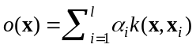. | (4)

Note that o is obtained without use of the bias term b which is not needed for positive definite kernels. (It is straightforward to expand the algorithms below with the bias b). Next, the minimization of loss functions (1) and (2) will be done in a stochastic way, meaning the value of the expansion parameter α_{j} will be updated after a single sample is presented. In other words, the gradients of R_{rhl} will be calculated without the summation over all data samples. Under such a stochastic update, the stochastic gradient descent for updating expansion coefficients α_{j} is given in [5-6], and called Naïve Online R Minimization Algorithm (NORMA). A slightly different learning algorithm is proposed in [7-8]. In [7] it is originally dubbed PEGASOS (standing for Primal Estimated sub-GrAdient SOlver for SVM). Both algorithms are shown below. The viol variable denotes the violator, i.e. the sample which lies on the wrong side of a separation boundary.

List 1: Norma Online Algorithm
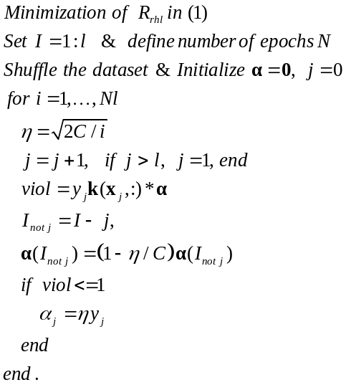

List 2: Pegaz Online Algorithm
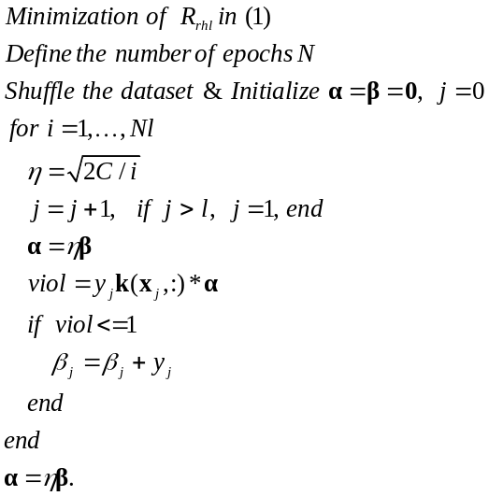
k(x_{j}, :) is the j-th row of the Gramm matrix of corresponding kernel. It contains the values of j-th kernel at all the other data points. k(:, x_{j}) is then a transposed k(x_{j}, :) meaning a column vector with same entries as k(x_{j}, :).

We have christened the algorithm in List 2 as Pegaz for the sake of differentiating between four SVM learning algorithms used here. Pegasos was the name given by same author to a similar stochastic gradient procedure in [7]. Here, the projection step from Pegasos is missing and the lines in List 2 are equal to the ones in [8]. Hence, the name just connects to the origin of the algorithm. As with all numerical iterative algorithms, there are several iteration hyperparameters one has to configure. The first variable to define in stochastic gradient descent procedures is the learning rate η. In the lists above, we have accepted the suggestion about the 'optimal stepsize' η as given in [11]. This choice is different but 'similar' to the suggestions given in [5-8]. Another important decision is setting how many iterations one will perform. They are defined by the number of epochs. While there are no clear guidelines, a rule of thumb would suggest that the bigger the datasets, the smaller the number of epochs should be. More about this issue can be found in our companion paper at the conference [12]. There is also an open issue on how to choose the final expansion parameter vector α. In [7] and [8], it is suggested to cache all the alpha updates, and then take the average as the final value of vector α. In [12], several strategies have been explored to define the final vector of expansion parameters α. More about this issue can be found there, but the overall suggestion is that taking the average over all the α_{i} stored may not always be the best strategy.
However, there is a more important point concerning the two online SVM algorithms shown. They use stochastic gradient descent for a minimization of R_{rhl} given in (1) and they should result in same final values of alpha vectors' entries, assuming that other simulation specifications (learning rate and order of data points selected) are equal. This is the case only if one makes a single pass through the dataset (number of epochs N = 1). For N > 1, they result in different solutions and neither the number of support vectors (data points having |α_{i}| value > 0) nor the α_{i} values are equal. An extensive experimental comparison on various datasets may give an answer to the question which of the two might be more preferable. This is not on our agenda here.
As mentioned earlier, one can devise a stochastic gradient model for training SVMs by only minimizing the soft margin loss given in (2). This is what we have done in the paper. This means that we have adopted the approach for the kernel perceptron learning algorithm given in [9], but we use the SVM's soft margin loss (2). Our algorithm used in all simulations here is shown in List 3.
In addition to being very simply structured, the OL SVM algorithm efficiency is improved by calculating viol variable with the help of the output vector o and by caching o only when there is a violation, i.e., an α_{j} update. Such a calculation of viol is more efficient. Namely, by using output vector o one avoids computing a dot product of l-dimensional vectors in each iteration step. Note that this speedup by calculating and using the output o can be implemented in Norma and Pegaz algorithms too, but this is not how they have been originally introduced.

List 3: SVM Online Algorithm - OL SVM
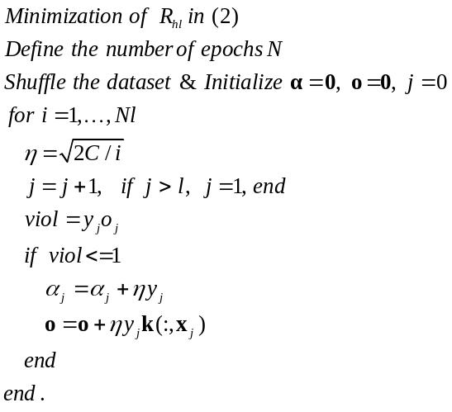

Finally, all three algorithms, after calculating the expansion vector α, have designed the SVM model which for every new input vector x makes the following decision
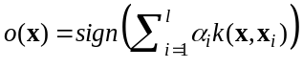. | (5)

The main task in this paper is to check the potential of the kernel perceptron like OL SVM algorithm obtained by minimizing only the soft margin loss (2) and given in List 3. We will present comparisons of OL SVM with the SMO based algorithm within the MATLAB environment. SMO is the most popular training algorithm for SVMs and it stands for Sequential Minimal Optimization [13]. MATLAB has recently implemented it within the routine fitcsvm [14]. The first batch of simulations and comparison results in section III are obtained by comparing the performances of OL SVM and fitcsvm. After this we'll show comparisons between the three online SVM algorithms given in the three lists.

Datasets and Results
Paper presents comparisons of two binary SVM classifiers -the SMO based fitcsvm and our implementation of OL SVM, on datasets that contain up to 15,000 samples. Basic information about the datasets used are presented in Table 1.
- Datasets Basic Information
Dataset | # Samples | # Features
cancer | 198 | 32
sonar | 208 | 60
vote | 232 | 16
eukaryotic | 2,427 | 20
prototask | 8,192 | 21
reuters | 11,069 | 8,315
chess board data | 8,000 | 2
Two normally distributed classes | 15,000 | 2

Data which originally are not binary have been transformed into binary classification problem by grouping the samples into two classes. For the eukaryotic dataset, results are shown for classifying class 4 vs the rest. The prototask dataset is transformed into a balanced two class problem, where if y_{i} >= 89 x_{i} is assigned to class 1, otherwise, the data belongs to class 2. In all simulations, the SVM with a Gaussian kernel have been used. The results shown are obtained by performing the 5-fold cross-validation. The two design hyper-parameters have been used out of the following range of parameters. The penalty parameter C ∈ [1e-4 1e-3 1e-2 1e-1 1e0 1e1 1e2 1e3 1e4], and the Gaussian shape parameter σ is different for each dataset. Typically, it is in the range [1e-1 1e0 1e1 1e2]. Such a set of 9 C and 4 σ values would lead to 36*5 = 180 runs for each dataset which can really be computationally expensive for bigger datasets. For example, the SMO algorithm based fitcsvm neded 2.7 days to finish the cross-validation runs for reuters data.
Table II shows the average error rates of SMO and OL SVM on test datasets. In all runs OL SVM is faster than SMO. With the increase in datasets size, the speedup increases.
- Average error rate and Speedup of OL SVM vs. SMO
Dataset | Error Rate SMO, % | Error Rate OL SVM, % | OL SVM is that time faster
cancer | 24.00 | 25.62 | 4.1
sonar | 34.70 | 24.35 | 3.68
vote | 22.68 | 8.09 | 1.89
eukaryotic, 4 vs rest | 36.05 | 14.55 | 5.67
prototask | 33.57 | 11.28 | 5.61
reuters | 5.65 | 4.48 | 4.10
chess board data | 13.62 | 4.27 | 7.65
Two normally distributed classes | 28.25 | 7.82 | 41.50

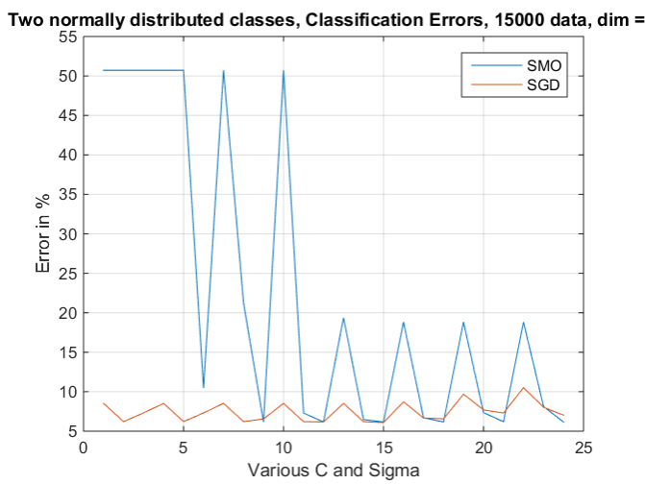
- Error rates of SMO and OLSVM algorithms for two normally distributed classes in 2-dimensional space. Number of samples is 15,000
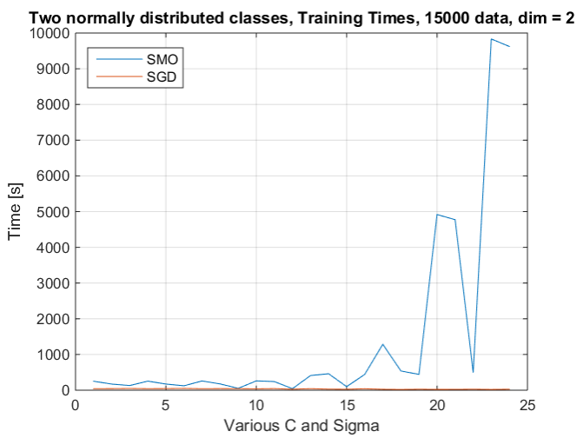
- CPU times of SMO and OLSVM algorithms for two normally distributed classes in 2-dimensional space. Number of samples is 15,000
Figs 1 and 2 show the typical and characteristic changes of error rates and CPU time for the two methods in 24 cross-validation runs (6 C and 4 σ values). For all datasets used here, the SMO based algorithm implemented in fitcsvm code has shown a known weakness of having long CPU training time for large values of both C and σ. There are two reasons for this. SMO is a kind of two coordinate descent, iterative algorithm which, for broad Gaussian kernels, iterates slowly to the bottom of cost function R_{rhl}, along the 'badly conditioned' valleys, or to the box defined by the C value. For a large C value, the box limits are very far from the origin, and one needs a lot of steps to reach them. On the other hand, the OL SMO is not influenced very much by the hyper-parameters values. Its CPU time is determined primarily by the number of iterations, which is defined by datasets cardinality and number of epochs N defined before the calculation.

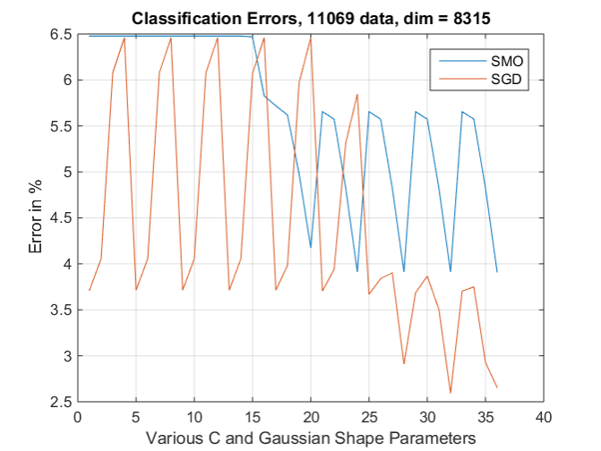
- Error rates of SMO and OLSVM algorithms for reuters dataset in 8,315-dimensional space. Number of samples is 11,069.
Figs 3 and 4 show the performances of SMO and OL SVM for the reuters data. This is a very sparse dataset (only 11,069 samples in 8,315 dimensional space). The curves in all simulation have a typical sew-saw behavior due to the order of selection of C and σ. Typically, one C is selected and it is being combined with all the shape parameters given. The last runs are with the largest values of C and σ.
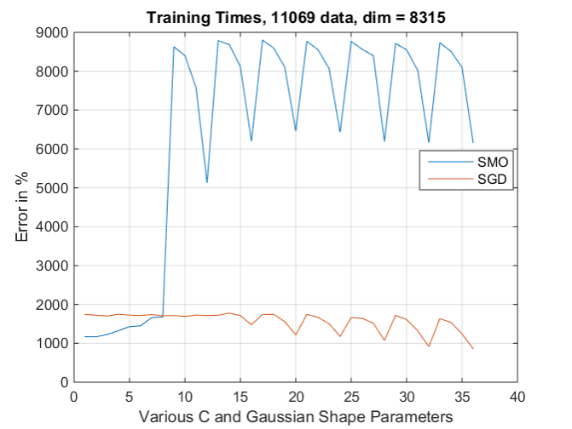
- CPU times of SMO and OLSVM algorithms for reuters dataset in 8,315-dimensional space. Number of samples is 11,069.
Next set of results shows the comparisons of the three stochastic gradient SVM algorithms introduced in section II (Norma, Pegaz and OL SVM) in our MATLAB implementation, on the chess board data containing 4,992 samples.
Figs 5 and 6 show the performances of the original algorithms given in the lists. Note that the Pegaz algorithm shown in List 2 does not include the projection step introduced in [7] for Pegasos. It is the stochastic algorithm from [8].
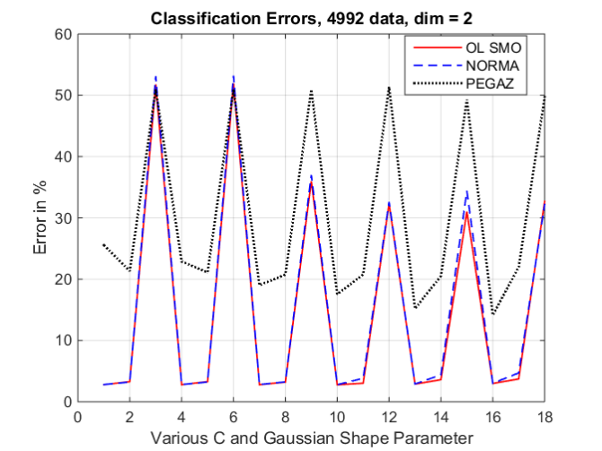
- Error rates of OLSVM, Norma and Pegaz algorithms for chessboard dataset in 2-dimensional space. Number of samples is 4,992. Performances of original algorithms given in the lists.

While the error rate of Norma and OL SVM are similar, OL SVM is 2 times faster than Norma and 4 times faster than Pegaz, in our implementations of the original algorithms. Pegaz’ error rates are higher than the ones shown by the other two online SVM algorithms.
In Figs. 7 and 8, all three algorithms are compared by using the same method of calculating violators as presented in List 3 for the here proposed OL SVM. This sped up Norma and Pegaz as it can be seen in Fig. 8, but OL SVM is still faster and more accurate than the other two stochastic gradient algorithms.

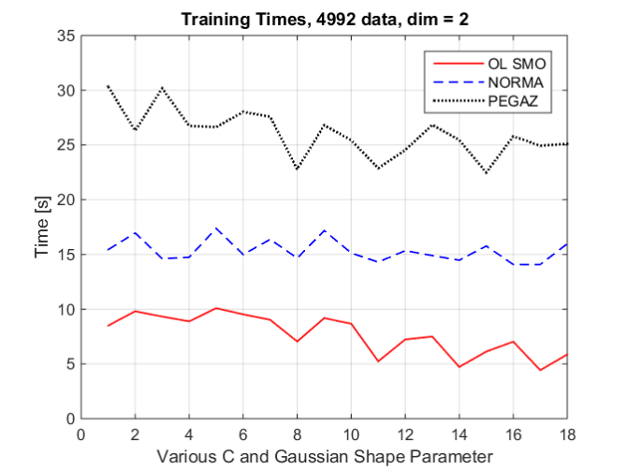
- CPU times of OLSVM, Norma and Pegaz algorithms for chessboard dataset in 2-dimensional space. Number of samples is 4,992. Performances of original algorithms given in the lists.

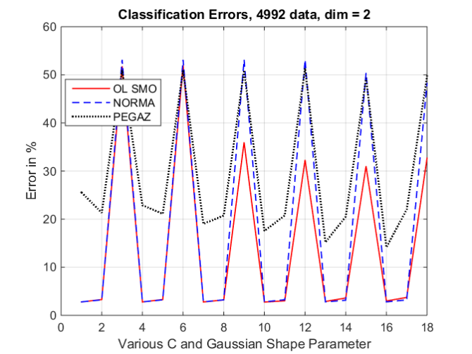
- Error rates of OLSVM, Norma and Pegaz algorithms for chessboard dataset in 2-dimensional space. Number of samples is 4,992. Violators are calculated as shown in the List 3.

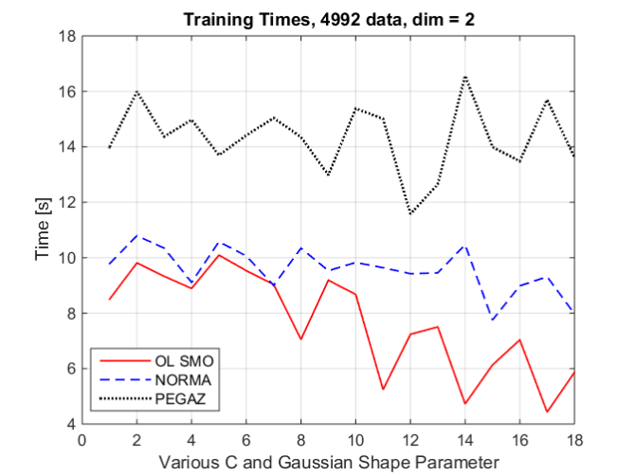
- CPU times of OLSVM, Norma and Pegaz algorithms for chessboard dataset in 2-dimensional space. Number of samples is 4,992. Violators are calculated as shown in the List 3.

Conclusions
The paper introduces stochastic gradient SVM learning algorithm in primal dubbed OL SVM. The algorithm is obtained by minimizing soft margin (a.k.a. hinge) loss without the quadratic regularization term. In this way, it has some similarities with the kernel perceptron learning algorithm expressed in dual variables. The known stochastic gradient algorithms, Norma and Pegaz, which minimize the original SVM loss function in primal, namely the regularized hinge loss, are also introduced and compared with OL SVM in MATLAB.
The comparisons between the classic and most popular SVM training approach, the SMO algorithm, and OL SVM on the MATLAB platform, show the superiority of OL SVM in terms of both accuracy and CPU time needed for performing the 5-fold cross-validations on various data. The experiments have been performed on several binary classification datasets, with up to 15,000 samples. Whether this superiority claim is right and valid for the implementation of the two algorithms on other platforms (C++, Java, Python, R) is partly answered in a companion paper [12] and it is still the subject of future investigations by using more datasets of various characteristics.
Paper also shows the performance comparisons of three stochastic gradient algorithms (OL SVM, Norma and Pegaz) on the chessboard dataset with 4,992 samples.
OL SVM has shown superiority in respect to the other two online methods. It needs less CPU time and it achieves higher accuracy than Norma and Pegaz. These results should be considered as the preliminary ones but they hint that OL SVM is highly likely very powerful algorithm. Our future work will be focused on implementing OL SVM in C++ and make it suitable for much larger datsets. The initial results presented in the companion paper at the conference [12], are very promising.

References

- Vapnik V., The Nature of statistical learning theory, Springer-Verlag, 1995.
- Cortes C. and Vapnik V., Support-vector networks, Machine Learning, 20(3), 1995, pp. 273–297.
- Kecman V., Vogt M., Huang T-M., On the Equality of Kernel AdaTron and Sequential Minimal Optimization in Classification and Regression Tasks and Alike Algorithms for Kernel Machines, Proc. of the 11th European Symposium on Artificial Neural Networks, ESANN 2003, Bruges, Belgium, 2003, pp. 215 – 222.
- Huang T.-M., V. Kecman, I. Kopriva, Kernel based algorithms for mining huge data sets, supervised, semi-supervised, and unsupervised learning, Springer-Verlag, Berlin, Heidelberg, 2005.
- Schoelkopf B., Smola A. J., Learning with Kernels - Support Vector Machines, Regularization, Optimization, and Beyond, MIT Press, 2002.
- Kivinen J., Smola A. J., Williamson R. C., Large Margin Classification for Drifting Targets, Neural Information Processing Systems, 2002.
- Shalev-Shwartz, Y. Singer, and N. Srebro. Pegaz: Primal estimated subgradient solver for SVM. In Proc. 24th Intl. Conf. on Machine Learning (ICML’07), pp. 807–814. ACM, 2007.
- S. Shalev-Shwartz and S. Ben-David, Understanding Machine Learning From Theory to Algorithms. New York: Cambridge University Press, 2014.
- Herbrich R., Learning Kernel Classifiers - Theory and Algorithms, The MIT Press, 2002.
- Collobert R., Bengio S., Links between Perceptrons, MLPs and SVMs, Proc. of the 21st Intl. Conf. on Machine Learning, Banff, Canada, 2004
- Ben-Taly A., Nemirovski A., Lectures on modern convex optimization, 2013.
- Melki G., Kecman V., Speeding-Up On-Line Training of L1 Support Vector Machines, Submitted to IEEE SoutheastConf, Norfolk, VA, 2016.
- Platt J. C., Sequential Minimal Optimization, A Fast Algorithm for Training Support Vector Machines, Microsoft Research, Technical Report MSR-TR-98-14, 1998
- MathWorks: http://www.mathworks.com/help/stats/fitcsvm.html, 2014

